**Description**

As a user, once I scroll past the Login/Register section, I should be able to view the “About App” section that defines the Mascot, describes how I could utilize financial charts, and how the Tamagotchi gets affected with consistent positive cashflow.

------------------------------------------------------------------------------------------------------------------------------------------

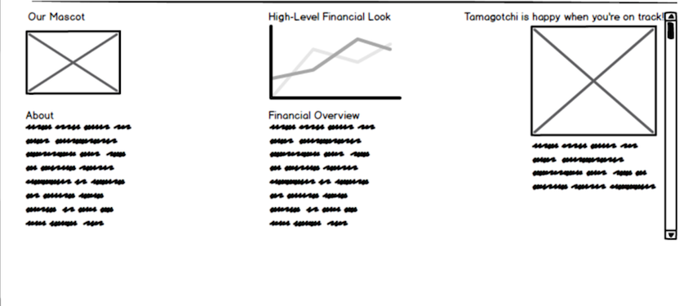

**Acceptance criteria**

* Displays content for Mascot, financial charts, and Tamagotchi moods/avatar change option